

|  |
| --- |
| **Project1 - Buyer/Seller matchmaking website**  **User Manual** |



Navigate to: [ec2-52-62-25-8.ap-southeast-2.compute.amazonaws.com/test2/project1/public](http://ec2-52-62-25-8.ap-southeast-2.compute.amazonaws.com/test2/project1/public)

1. Account - Register
2. Login / Logout
3. View seller’s posts which is sorted by user interest
4. View seller’s posts
5. View buyer’s posts
6. Navigation bar
7. View buyer/seller’s user profile and post history
8. View product description of the post / Contact seller or buyer
9. Search items (search bar)
10. Create post
11. Account details (My account) / Delete account
12. Edit profile
13. Change password
14. My post history / Delete post / Edit post
15. View admin functionality

### **1. Register**

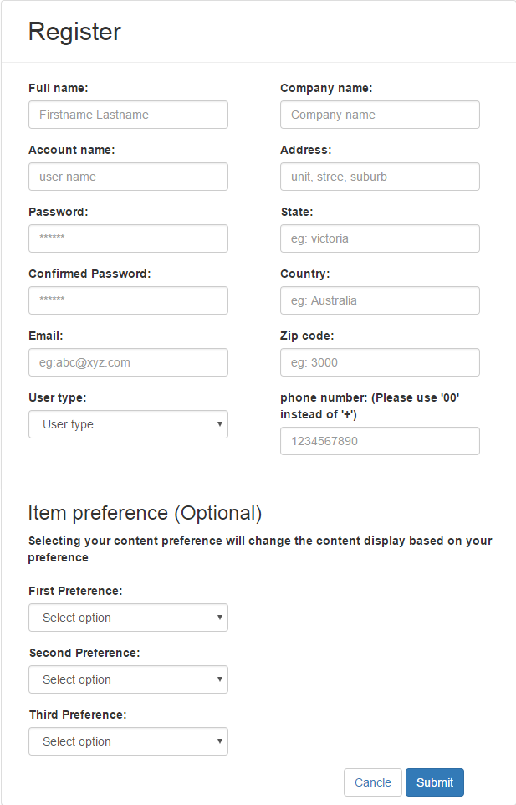

1. Navigate to the website:

<http://ec2-52-62-25-8.ap-southeast-2.compute.amazonaws.com/test2/project1/public>

1. Click on the sign up button
2. Fill out the Name field (Firstname Lastname)
3. Fill out the Account Name field (User account name)
4. Fill out the Password field (Password must be at least 6 characters, must contains at least one uppercase, one lowercase and one number)
5. Confirm the password chosen by typing it again into the Confirmed Password field
6. Fill out the Email field
7. Select the User type
8. Fill out the Company Name field
9. Fill out the Address field
10. Fill out the State field
11. Fill out the Country field
12. Fill out the Zip code field
13. Fill out the Phone number field
14. Choose the Item preference field (It is optional)

a. Choose the First Preference field (optional)

b. Choose the Second Preference field (optional)

c. Choose the Third Preference field (optional)

1. Finish register the account by pressing the Submit button

a. If successful, you will be redirected to the Login page

b. If validation fails, you will be notified on the form requirements such as:

- The username field is required

- The confirm password must be at least 6 characters

- The zip number must be a number

1. If you wish to cancel registration click the Cancel button

a. If successful, you will be redirected to the Login page

### **2. Login / Logout**

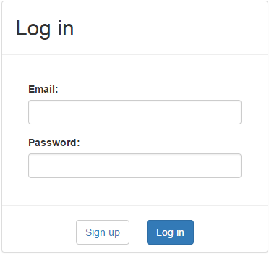

< Login >

1. Navigate to the Login page: <http://ec2-52-62-25-8.ap-southeast-2.compute.amazonaws.com/test2/project1/public>
2. Fill out the Email Address field
3. Fill out the Password field
4. Click on Login and you will be redirected to the Dashboard(index) page

** User must be logged in to navigate whole website except Register page and Login page.



< Logout>

1. While logged in, throughout the website you have the option to logout by clicking/pressing the Logout button located on top right of the page

a. If successful, you will be redirected to the login page and be noticed “You have successfully logged out” message.

### **3. View seller’s posts which is sorted by user interest**

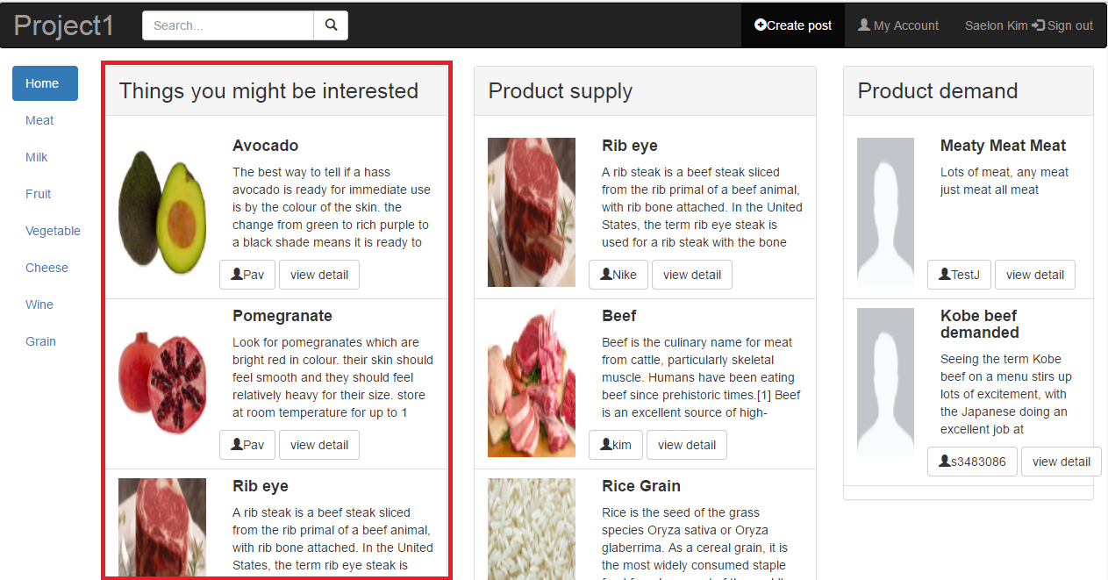

1. Navigate to Index page: <http://ec2-52-62-25-8.ap-southeast-2.compute.amazonaws.com/test2/project1/public/index>
2. View Things you might be interested section in the left second of the dashboard which includes the image of post, the post title, the post description, the user id of post and the view detail button.

### **4. View seller’s posts**

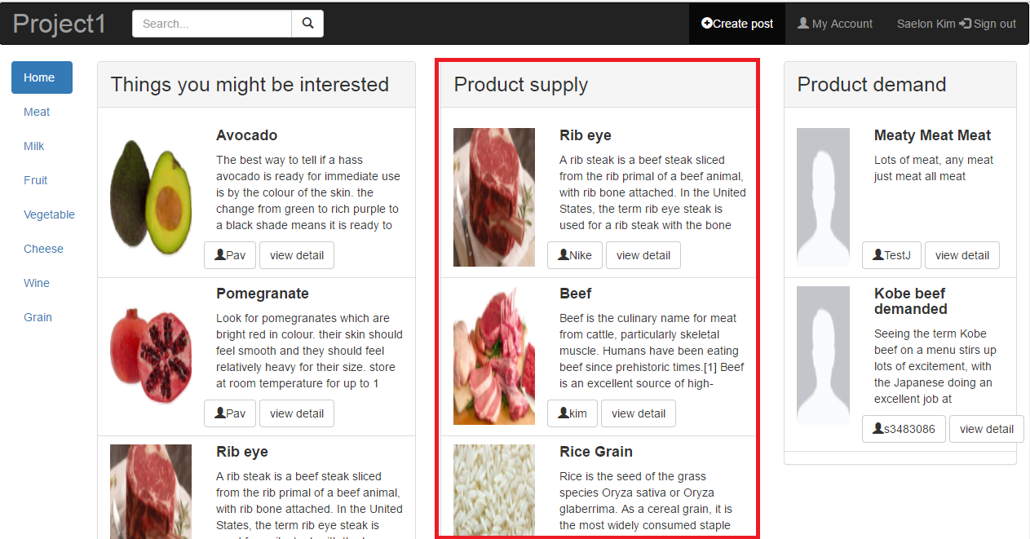

1. Navigate to Index page: <http://ec2-52-62-25-8.ap-southeast-2.compute.amazonaws.com/test2/project1/public/index>
2. View Product supply section in the right second of the dashboard which includes the image of post, the post title, the post description, the user id of post and the view detail button.

### **5. View buyer’s posts**

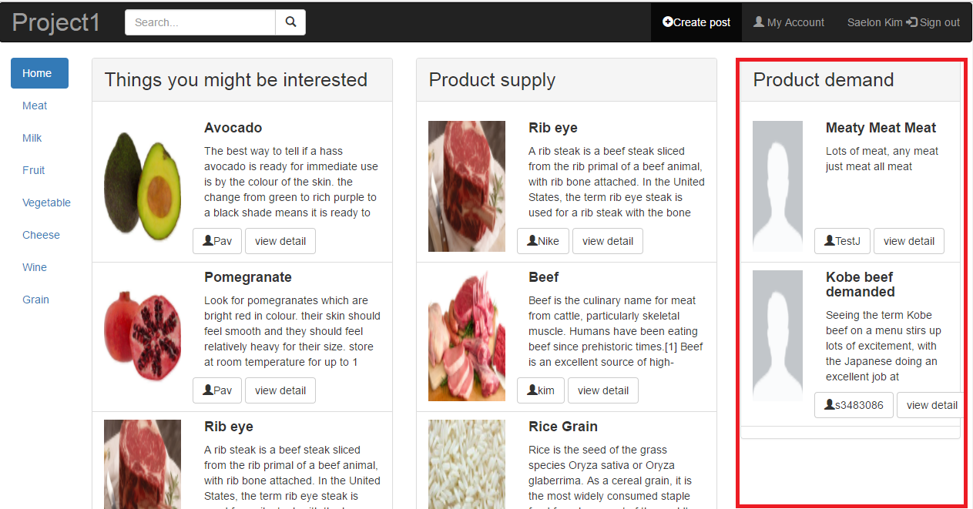

1. Navigate to Index page: <http://ec2-52-62-25-8.ap-southeast-2.compute.amazonaws.com/test2/project1/public/index>
2. View Product demand section in the right first of the dashboard which includes the image of buyer, the buyer post title, the buyer post description, the user id of buyer post and the view detail button.

### **6. Navigation bar**

|  |  |
| --- | --- |
|  |  |
| < Navigation bar > | < Click Meat - The page is redirected to display all meat posts > |

1. Navigate to Index page: <http://ec2-52-62-25-8.ap-southeast-2.compute.amazonaws.com/test2/project1/public/index>
2. Click the Meat category and you will be redirected to the display all meat posts page
3. Click the Milk category and you will be redirected to the display all milk posts page
4. Click the Fruit category and you will be redirected to the display all fruit posts page
5. Click the vegetable category and you will be redirected to the display all vegetable posts page
6. Click the Cheese category and you will be redirected to the display all cheese posts page
7. Click the Wine category and you will be redirected to the display all wine posts page
8. Click the Grain category and you will be redirected to the display all grain posts page
9. Click the Home button and you will be redirected to the Index page.

### **7. View buyer/seller’s user profile and post history**

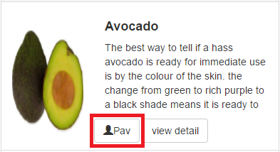

1. Navigate to the website
2. Click on the user id button of buyer or seller which is in the bottom left of the post. Once you click the user id button, you will be redirected to User profile page.
3. View User profile dashboard which includes the image of user, the full name of user, the user id, the phone number, the email address and the post histories of user.

### **8. View product description of the post / Contact seller or buyer**

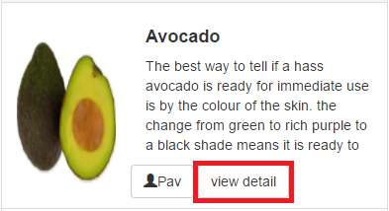

< View detail – type (1) >

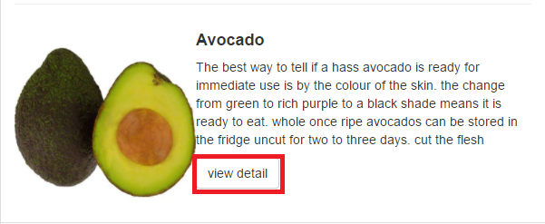

< View detail – type (2) >

1. Navigate to the website
2. Click on the View detail button of buyer or seller post. Once you click the button, you will be redirected to Product description page

|  |
| --- |
|  |
| < Product description page > |
|  |
| < Security protection window pops up when user clicks Contact Seller (or Buyer) button > |

1. View Product description dashboard which includes the post title, the buyer/seller user name, the encrypted buyer/seller contact number, the encrypted buyer/seller email address, the post created date and time, the updated date and time, the type if item, and image of item and the post description
2. Click the Contact Seller (or Buyer) button to unseal the hidden contact number and email address. Once you click the Contact Seller (or Buyer) button, you will get the Security protection window.
3. Click the box on the left side of “I am not a bot” message
4. Click the Submit button in the right corner of the Security protection window.

### **9. Search items (search bar)**



1. Navigate to the website
2. Click the search box in the left second top of the website and type specific keyword that you want to search
3. Press enter key on your keyboard or click on the magnifying glass button and you will be redirected to the search result page which is matched by keyword that you typed in

** Search function doesn’t search buyer’s posts or information. Search function ONLY search seller’s posts or information.

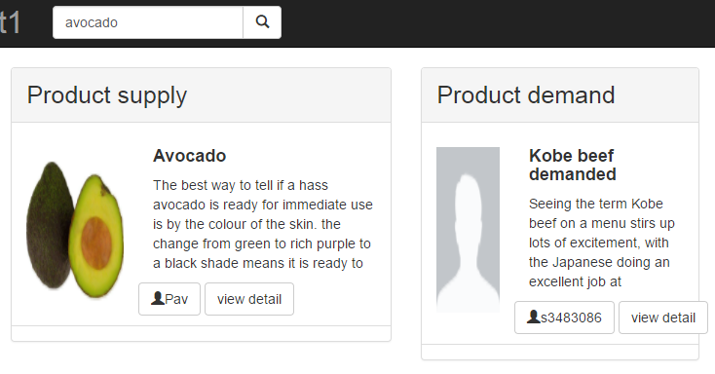

### **10. Create post**

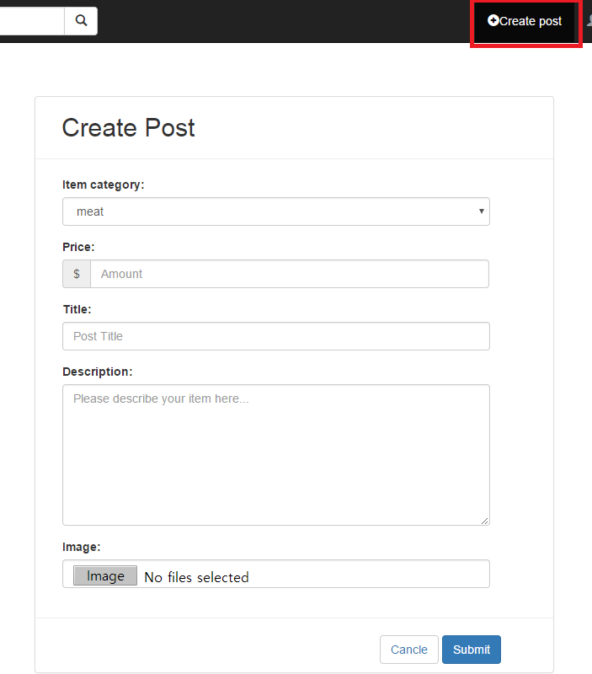

1. Navigate to the website
2. Click the Create post button in the third right top of the website and you will be redirected to the Create post page
3. Select the Item category
4. Fill out the Price field (Number only. Example: 20.00)
5. Fill out the Title field (Example: Fresh beef for sale!)
6. Fill out the Description field (Describe your item to sell or buy)
7. Click the Image button and upload your product image in your computer folder
8. Finish creating post by pressing the Submit button

a. If successful, you will be redirected to the Index page

b. If validation fails, you will be notified on the form requirements such as:

- The price field is required

- The image field is required

### **11. Account details (My account) / Delete account**



1. Navigate to the website
2. Click the My account button in the right second top of the website and you will be redirected to the Account details page
3. You can see your account detail in this page

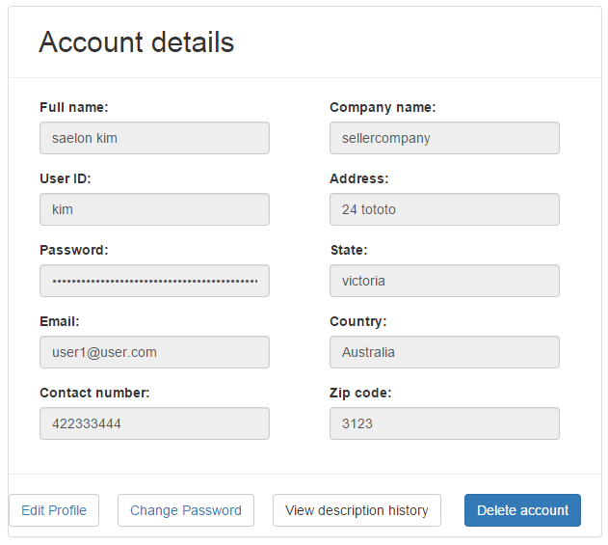

1. Click the Delete account button in the bottom end of the dashboard and you will be redirected to the Login page.

** Once you delete your account, you will not be able to retrieve it. Also all your posts will be deleted.

### **12. Edit profile**

1. Navigate to the My account page: <http://ec2-52-62-25-8.ap-southeast-2.compute.amazonaws.com/test2/project1/public/my_account>

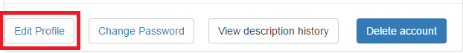

1. Click the Edit profile button in the bottom first of the dashboard and you will be redirected to the Edit profile page

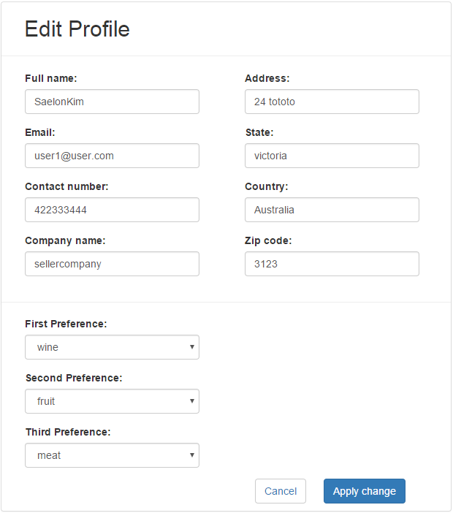

1. Edit the Full name field
2. Edit the Email field
3. Edit the Contact number field
4. Edit the Company name field
5. Edit the Address field
6. Edit the State field
7. Edit the Country field
8. Edit the Zip code field
9. Select the First preference (optional)
10. Select the Second preference (optional)
11. Select the Third preference (optional)
12. Finish editing user profile by pressing the Apply change button

a. If successful, you will be redirected to the My account page and be notified by “your profile has been updated” message

b. If validation fails, you will be notified on the form requirements such as:

- The fname (full name) may only contain letters

- The email field is required

- The phonenum (phone number) must be between 10 and 13 digits

1. If you wish to cancel editing your profile click the Cancel button

a. If successful, you will be redirected to the My account page

### **13. Change password**

1. Navigate to the My account page: <http://ec2-52-62-25-8.ap-southeast-2.compute.amazonaws.com/test2/project1/public/my_account>

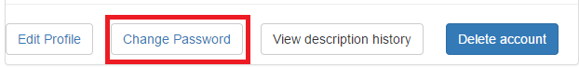

1. Click the Change Password button in the bottom second of the dashboard and you will be redirected to the Change Password page

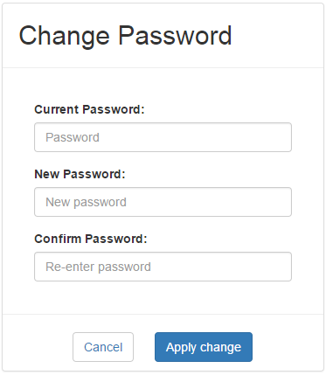

1. Fill out the Current password field
2. Fill out the New password field
3. Fill out the Confirm password field (Confirm password must match with New password)
4. Finish changing your account password by pressing the Apply change button

a. If successful, you will be redirected to the My account page and be notified by “Your password has successfully changed!” message

b. If validation fails, you will be notified on the form requirements such as:

- Current password and new password should not be the same, please try again

- The current password field is required

1. If you wish to cancel editing your account password click the Cancel button

a. If successful, you will be redirected to the My account page

### **14. My post history / Delete post / Edit post**

1. Navigate to the My account page: <http://ec2-52-62-25-8.ap-southeast-2.compute.amazonaws.com/test2/project1/public/my_account>

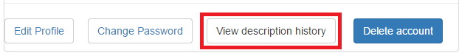

1. Click the View description history button in the bottom third of the dashboard and you will be redirected to the User profile page

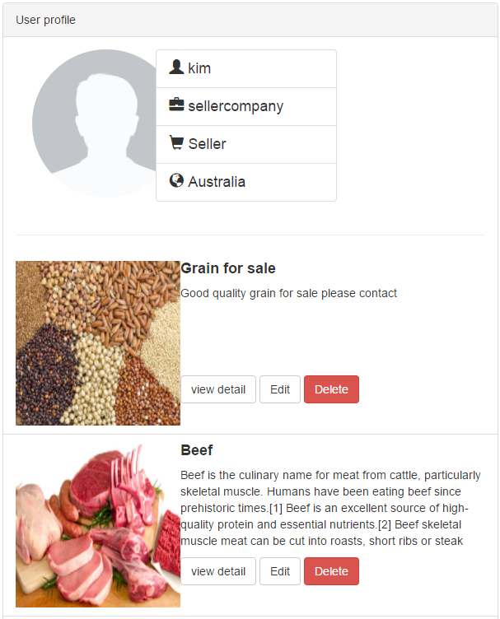

< Delete Post >

1. Click the Delete button in your post box. You will be notified “Your post has been deleted” message and be stayed in User profile page.

** Once you delete your post, you will not be able to retrieve it. All your posts will be deleted from the database.

< Edit Post >

1. Click the Edit button in your post box and you will be redirected to Edit post page

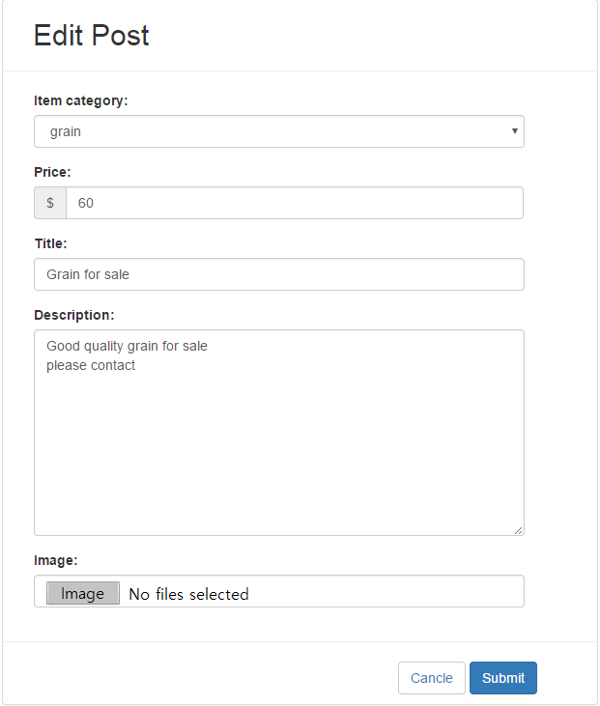

1. Select the Item category field
2. Edit the Price field
3. Edit the Title field
4. Edit the Description field
5. Select the Image from your computer folder by clicking Image button
6. Finish changing your post by pressing the Submit button

a. If successful, you will be redirected to the Index page

b. If validation fails, you will be notified on the form requirements such as:

- **empty title, description -> bug (undefined variable: categories (view: /var/www/html/test2/project1/resources/views/layouts/edit_post.blade.php)**

1. If you wish to cancel editing your account password click the Cancel button

a. If successful, you will be redirected to the Index page

### **15. View admin functionality**

1. Navigate to the admin login page: <http://ec2-52-62-25-8.ap-southeast-2.compute.amazonaws.com/test2/project1/public/admin/login>
2. Log in as Admin

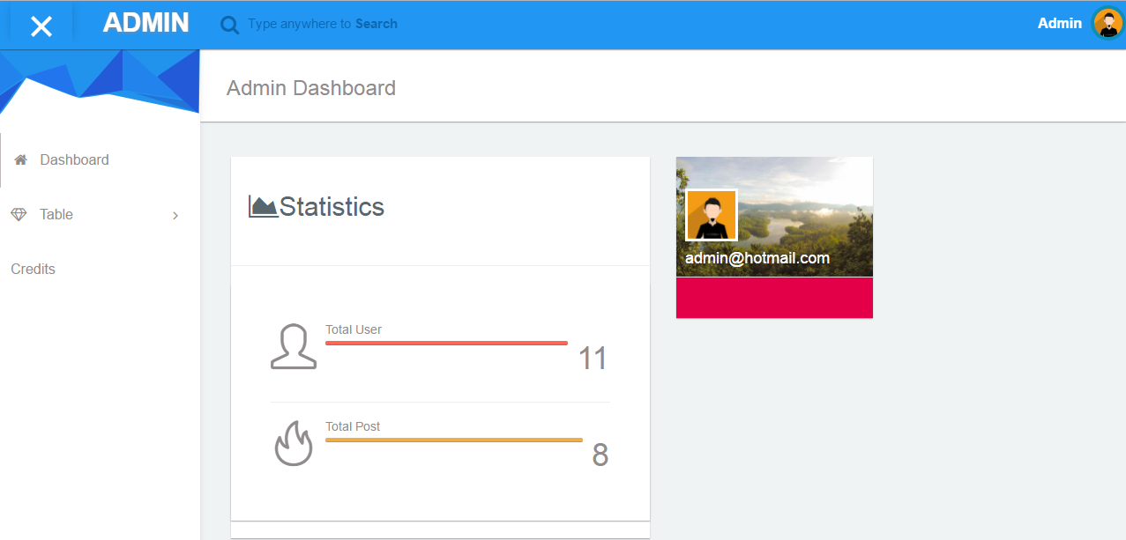

< Admin dashboard >

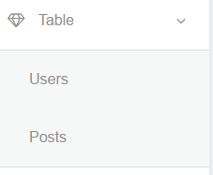

1. Click the Table in the left navigation bar
2. Select the Users from the drop down menu
3. Delete User Account from the Data tables
4. Select the Posts from the drop down menu
5. Delete User Posts from the Data tables